  MONDAY 8th – 10.30 AM |  |  |   MONDAY – 2.00PM
General Knowledge Quiz (Heron House) |  |  | The Singers Group  - (The Pantry)
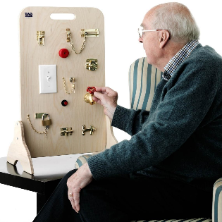  TUESDAY 9th – 10.30 AM |  |  |   TUESDAY – 2.00PM
1:1 Activities  - (Robin and Dove) |  |  | Chris Snelling Piano  - (The Pantry)
W
  WEDNESDAY 10th– 10.30 AM |  |  |   WEDNESDAY – 2.00PM
Biscuits decoration  - (Heron House) |  |  | Poetry  - (Heron House)
  THURSDAY 11th – 10.30 AM |  |  |   THURSDAY – 2.00 PM
Prayer Morning Jenny 11am  - (Swan House) |  |  | Garden Stroll  - (Puffin Garden)
  FRIDAY 12th – 10.30 AM |  |  |   FRIDAY – 2.00 PM
Wildlife Watching  - (Puffin Garden) |  |  | Film afternoon  - (Oscar’s Cinema)
Weekly activities

8th – 12th April
Typical Activities

(Example Week 1)
Typical Activities

(Example Week 1)

